**Information sheet about the 2023 SHOT, MHRA and UKTLC safety culture survey:**

### Why?

* Measuring patient safety culture from the perspective of staff can provide insights that lead to improvements in care. Healthcare staff are often the first to identify concerning patterns of unsafe practice and the conditions which increase or decrease the likelihood of such practice
* Sharing your experiences can help to identify what is working well and what needs to improve
* As you may be aware, in 2019, a survey was undertaken to examine safety culture within transfusion laboratories following anecdotal evidence of blame culture within transfusion laboratories. This survey found evidence albeit from a small number of responses received that a just and learning culture was not being effectively employed within the NHS transfusion services (click [here](https://www.shotuk.org/wp-content/uploads/myimages/Transfusion-laboratories-culture-survey-report-updated-13-09-19.pdf) for the survey report). Several measures have been undertaken since then to address this including disseminating the results of the survey widely, developing resources such as SHOT Bites relating to safety culture and raising concerns, and promoting awareness through webinars and other meetings
* This survey is being carried out jointly by SHOT, MHRA and UK Transfusion Laboratory Collaborative (UKTLC) to gain information about the current safety culture within laboratories so as to identify and facilitate improvements and enhance safety

### What?

* The patient safety culture survey will take about 15-20 minutes to complete and will ask about your perceptions and experiences at work, such as teamwork, communication and reporting of patient safety incidents

### When?

* The survey will be available for a two-week period from 08 Nov 2023 to 22 Nov 2023

### Who?

* The culture survey is mainly focusing on laboratory staff both in hospitals and Blood Services, but all staff are welcome to participate. We would like to get input from as many transfusion laboratory staff as possible to get an accurate picture of safety culture, so please feel free to share this link with transfusion professional colleagues

### How?

You can access the survey via the link attached to the email sent to all laboratory managers. Please contact the SHOT team [shot@nhsbt.nhs.uk](mailto:shot@nhsbt.nhs.uk) to request a copy

* **We would like your views** on whether you feel there is a positive safety culture in your organisation, and by answering this survey you can contribute to future work by SHOT, the MHRA and UKTLC work to improve transfusion safety
* This anonymous survey should be completed by individuals regarding their own viewpoints and should NOT be completed by one person on behalf of teams. Please only complete the survey once, even if it has been received from multiple sources
* All responses and comments are anonymised; however we encourage you to refrain from providing information which could identify your(self), any individual and/or your organisation
* Reminders will be sent from SHOT 1 week and 2 days before the closing date
* If you select the ‘Finish later’ option, the system will automatically contact you with reminders

### What next?

* The data collected from the survey will be analysed and the survey report including a summary report will be uploaded onto the SHOT website in due course and cascaded widely
* All data will be de-identified and will not be linked to respondents. Identifying information will be removed from verbatim comments
* An action plan will also be included in the survey report to address the key issues identified and facilitate improvements at a national level

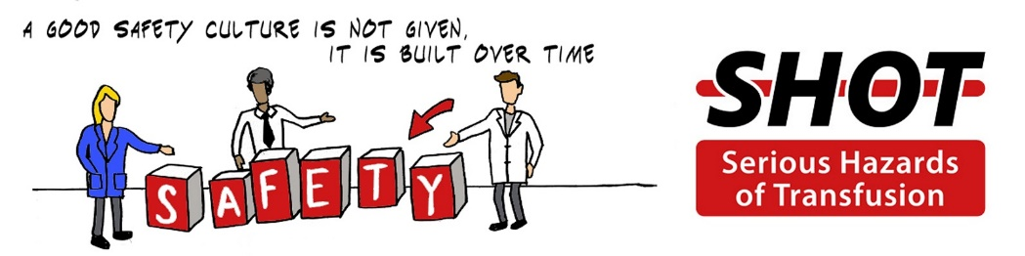

***The SHOT team, MHRA and UKTLC would like to thank you all for the time you have taken to complete this questionnaire and we are committed to utilise the information gained to facilitate improvements. Once again, we are extremely grateful to you all for contributing your valuable time, your honest information, and your thoughtful suggestions.***

If you have any questions about the survey or the process, you can contact: [shot@nhsbt.nhs.uk](mailto:shot@nhsbt.nhs.uk)